**NANDHA ENGINEERING COLLEGE**

**(Autonomous Institution)**

Erode-638 052



**TABLEAU-TWO CREDIT COURSE**

**IV – Semester**

**B.Tech - Artificial Intelligence and Data Science**

**NAME : ABEL SHAJI**

**BRANCH : B.TECH AI & DS**

**YEAR : II**

**TABLEAU**

Tableau is a leading data visualization and business intelligence platform that transforms complex HR data into clear, actionable insights. Renowned for its user-friendly interface, Tableau enables HR professionals, even those without technical expertise, to create interactive dashboards, dynamic charts, and comprehensive reports. By connecting seamlessly to HR systems like Workday, SAP SuccessFactors, or Excel, Tableau facilitates real-time analysis of workforce metrics such as employee performance, turnover rates, and diversity trends. Its drag-and-drop functionality and robust visualization capabilities empower HR teams to identify patterns, monitor key performance indicators (KPIs), and make data-driven decisions to enhance employee engagement and organizational success. With Tableau, HR departments can present compelling, visually appealing insights to stakeholders, fostering strategic workforce planning and improved outcomes.

**AMAZON SALES ANALYSIS**

* It is raw data collected from sales activities on Amazon’s platform.
* It mainly contains information like product name, price, quantity sold, order date, shipping cost, customer location, and return status.
* This data records every sale event made on Amazon.

**Use Case of Amazon Sales Analysis Data:**

* It is used to analyze and track business performance on Amazon.
* Typical use cases include:
* Sales tracking: Monitor how much revenue is being generated.
* Inventory management: Understand which products need restocking.
* Performance reporting: Create monthly or quarterly sales reports.
* Market research: Identify popular products and customer buying trends.
* Pricing optimization: Adjust product prices based on sales performance.

**SHEET 1: PRODUCT VS TOTAL SALES**

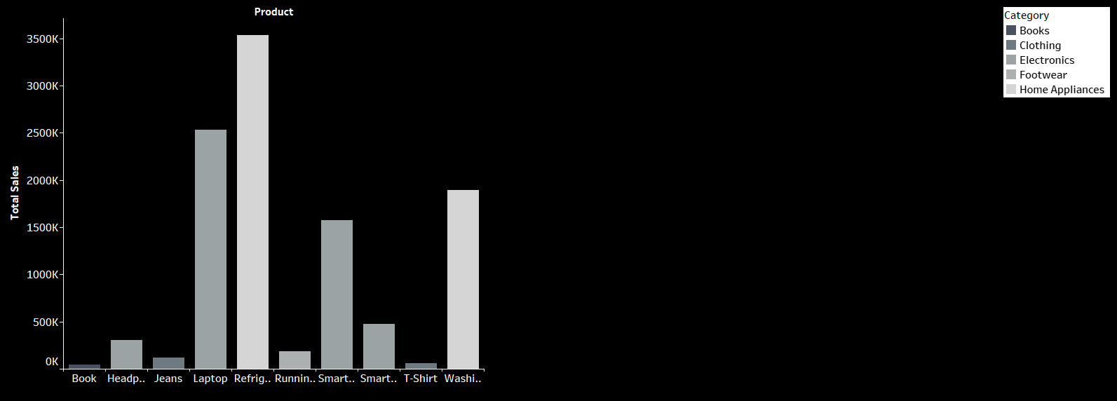

**Top Performers:**

* Refrigerators have the highest sales, suggesting strong demand for Home Appliances.
* Laptops are the second-highest, highlighting Electronics as a major sales driver.

**Mid-Range Products:**

* Washing Machines (Home Appliances) and Smartphones (Electronics) have good but lower sales compared to the top two.

**Low Performers:**

* Books, Jeans, T-Shirts, and Running Shoes show minimal sales, meaning Clothing and Books categories perform poorly here.

**Category Trends:**

* Home Appliances overall have higher sales compared to Clothing and Footwear.
* Electronics are also strong, with several products (Laptop, Smartphone, Smartwatch, Headphones) performing decently.

**Visual Design:**

* Dark background with different shades for each category improves readability.
* Sales are marked on the Y-axis, with products on the X-axis, and a clean legend on the right.

**SHEET 2 :** **SALES OVER TIME (LINE CHART)**

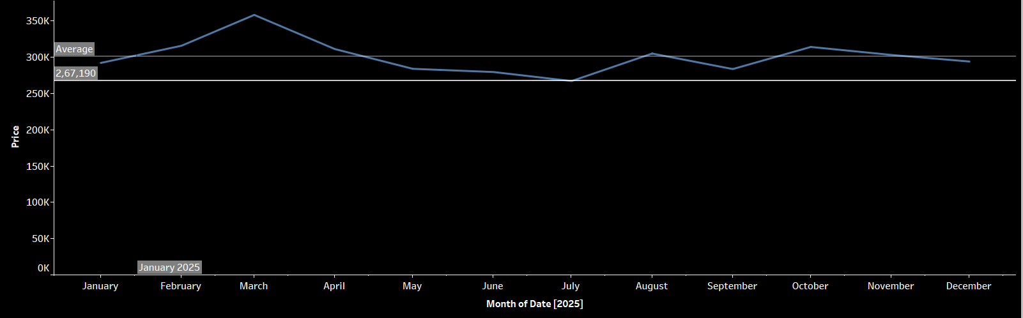

The chart provides a detailed view of the price trend throughout 2025, with the y-axis representing price in increments of 50,000 up to 350,000 and the x-axis labeling each month from January to December. The average price, highlighted at 267,190, serves as a reference line across the chart.

Starting in January, the price is approximately 300,000, showing a slight upward trend into February and peaking just above 300,000 in March. From April onward, the price begins a gradual decline, with noticeable dips around June and July, where it approaches its lowest point, potentially near 250,000. A modest recovery occurs from August, with a more significant increase in September and October, pushing the price back toward 300,000. By November and December, the price stabilizes, hovering around or slightly below the average of 267,190.

This pattern suggests an initial rise followed by a prolonged period of decline, a brief recovery in the latter half of the year, and eventual stabilization. The fluctuations may indicate seasonal influences, market adjustments, or other external factors, though specific causes cannot be determined from the chart alone.

**SHEET 3:** **CATEGORY SALES**

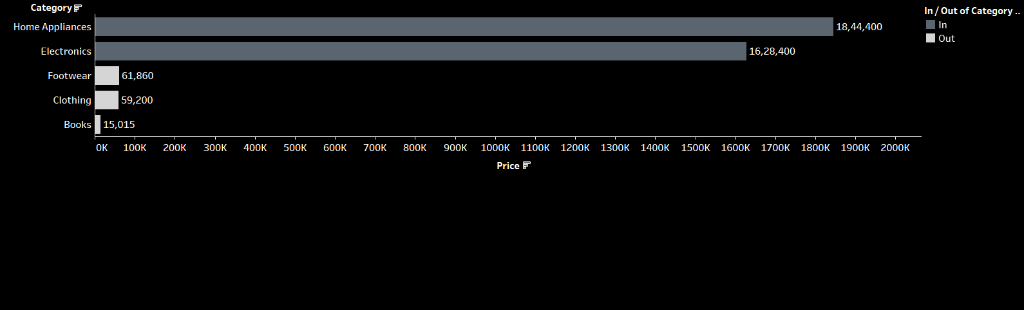

The chart is a horizontal bar graph that compares the average prices of various product categories, with the x-axis representing price in increments from 0 to 200,000 and the y-axis listing the categories: Home Appliances, Electronics, Footwear, Clothing, and Books. Each category is accompanied by a specific average price, and the bars are color-coded to indicate whether they fall within the "In" or "Out" category range, likely based on a price threshold around 100,000.

* Home Appliances top the list with an average price of 184,400, extending significantly into the "In" category range, suggesting they are among the highest-priced items.
* Electronics follow with an average price of 162,840, also within the "In" category, indicating a high price point but slightly below Home Appliances.
* Footwear has an average price of 61,860, Clothing is at 59,200, and Books are the lowest at 15,015, all falling into the "Out" category range, reflecting their lower cost compared to the "In" items.
* The "In/Out of Category" distinction appears to split the categories into two groups: those exceeding the approximate 100,000 threshold (Home Appliances and Electronics) and those below it (Footwear, Clothing, and Books).

This price segmentation highlights a notable divide, with Home Appliances and Electronics likely representing durable or premium goods, while Footwear, Clothing, and Books are more affordable, everyday items. The wide price gap between the top two categories and the others may reflect differences in production costs, market demand, or perceived value. The chart effectively illustrates this hierarchy, with Home Appliances leading, followed by Electronics, and a steep drop to the lower-priced categories.

SHEET 4: ORDER DETAILS

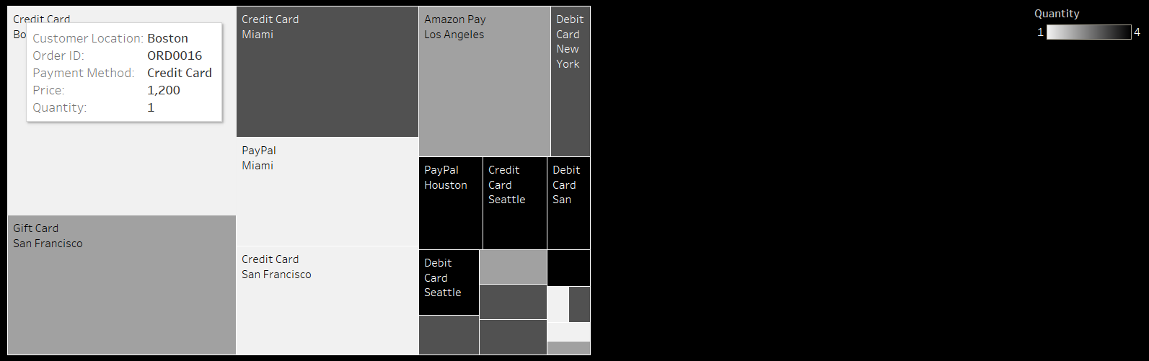

The chart is a heatmap that visualizes transaction data based on payment methods and customer locations, with rows representing payment methods (Credit Card, Amazon Pay, PayPal, Debit Card, Gift Card) and columns representing customer locations (Boston, Miami, Los Angeles, New York, Houston, Seattle, San Francisco). The color intensity reflects the quantity of transactions, ranging from 1 (light gray) to 4 (dark gray), with a gradient scale provided on the right.

* **Credit Card**: This is the most widely used payment method. Boston shows the highest transaction quantity at 4, indicating significant usage. San Francisco follows with a quantity of 3, suggesting strong activity there as well. Miami, Los Angeles, and Seattle each have a quantity of 1 or 2, showing moderate to low usage. A specific transaction from Boston is detailed with Order ID ORD0016, a price of 1,200, and a quantity of 1.
* **Amazon Pay**: Usage is limited to Los Angeles and New York, both with a quantity of 1, indicating minimal adoption in these locations.
* **PayPal**: Transactions occur in Miami (quantity 2) and Houston (quantity 1), with no activity in other locations, suggesting a moderate presence in these areas.
* **Debit Card**: Usage is spread across New York (quantity 2), Seattle (quantity 1), and San Francisco (quantity 1), showing a modest but varied distribution.
* **Gift Card**: Activity is restricted to San Francisco with a quantity of 1, indicating very limited use.

The heatmap reveals Credit Card as the dominant payment method, particularly in Boston and San Francisco, likely due to customer preference or merchant acceptance. Other methods like Amazon Pay and Gift Card have niche usage, confined to specific locations, while PayPal and Debit Card show moderate activity in select cities.

**SHEET 5:** **CLUSTERING**

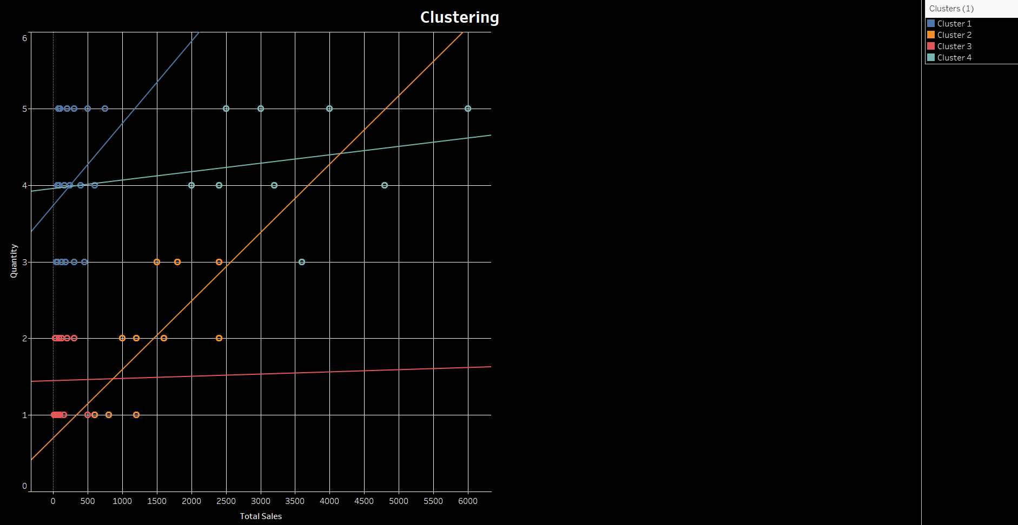

The chart is a scatter plot titled "Clustering," which displays data points grouped into four clusters based on two variables: "Total Sales" (x-axis, ranging from 0 to 6,000) and "Activity" (y-axis, ranging from 0 to 6). The clusters are color-coded as follows: Cluster 1 (blue), Cluster 2 (red), Cluster 3 (orange), and Cluster 4 (cyan), with a legend on the right.

* Cluster 1 (Blue): These points are concentrated in the upper-left quadrant, with Activity levels around 4 to 5 and Total Sales ranging from 0 to 1,500. This suggests a high activity level with relatively low sales.
* Cluster 2 (Red): Located near the bottom-left, with Activity around 1 and Total Sales from 0 to 1,500. This indicates low activity and low sales.
* Cluster 3 (Orange): Positioned along a diagonal from the bottom-left (Activity 1, Sales 0) to the upper-right (Activity 5, Sales around 5,500), showing a strong positive correlation between increasing activity and sales.
* Cluster 4 (Cyan): Spread across the middle, with Activity levels around 3 to 5 and Total Sales from 1,500 to 4,000, indicating moderate to high activity with moderate sales.

The chart suggests that Cluster 3 has the strongest relationship between activity and sales, while Cluster 1 shows high activity with lower sales, and Cluster 2 indicates low activity and sales. Cluster 4 represents an intermediate group with balanced activity and sales.

**DASHBOARD 1: AMAZON SALES ANALYSIS**

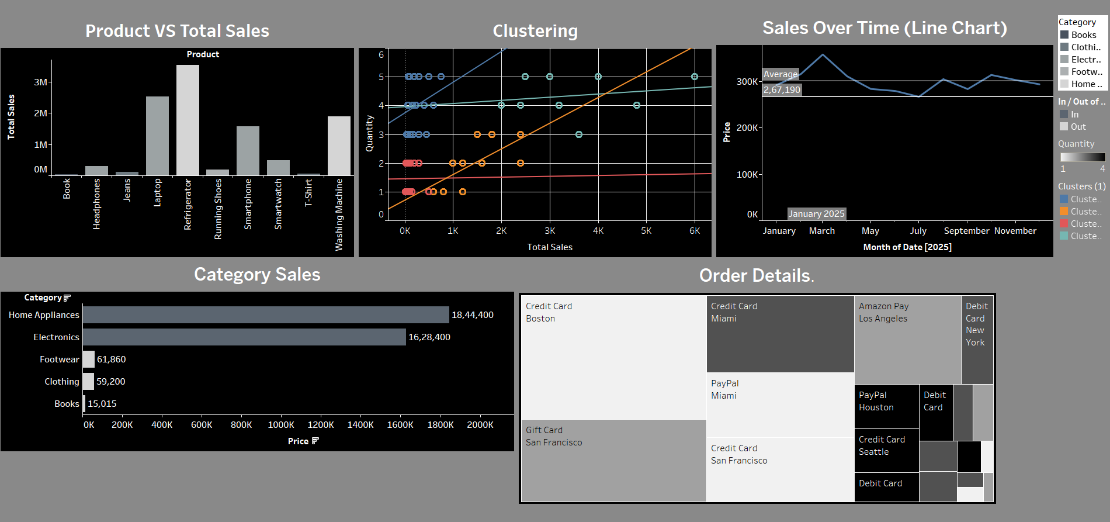

The dashboard consists of five visualizations, each providing insights into sales and transaction data from different perspectives. Here's a detailed explanation of each component:

1. **Product VS Total Sales (Top Left - Histogram)**

This histogram shows total sales for various products on the y-axis (up to 3M) against specific products on the x-axis.

* + T-Shirts lead with the highest sales, close to 3M, followed by Smartphones at around 2M.
  + Other products like Refrigerators, Washing Machines, and Smartwatches have sales around 1M to 1.5M.
  + Books, Jeans, Laptops, Headphones, and Running Shoes have the lowest sales, below 1M.  
    This indicates that T-Shirts and Smartphones are the top-selling products, while Books and similar items lag significantly.

1. **Clustering (Top Middle - Scatter Plot)**

This scatter plot groups data into four clusters based on Total Sales (x-axis, 0 to 6,000) and Activity (y-axis, 0 to 6).

* + Cluster 1 (Blue): High activity (4-5) but low sales (0-1,500), suggesting high engagement with minimal revenue.
  + Cluster 2 (Red): Low activity (around 1) and low sales (0-1,500), indicating underperforming segments.
  + Cluster 3 (Orange): Shows a strong positive correlation between activity and sales, ranging from (1, 0) to (5, 5,500), indicating that higher activity drives higher sales.
  + Cluster 4 (Cyan): Moderate activity (3-5) and sales (1,500-4,000), representing a balanced segment.  
    This suggests Cluster 3 is the most efficient in converting activity to sales, while Cluster 1 may need strategies to boost revenue despite high activity.

1. **Sales Over Time (Line Chart) (Top Right)**

This line chart tracks price (y-axis, up to 350,000) over the months of 2025 (x-axis). The average price is 267,190.

* + The price starts at around 300,000 in January, peaks slightly above this in March, then declines to a low near 250,000 around June/July.
  + It rises again in September/October, nearing 300,000, before stabilizing around 267,190 by December.  
    This shows a general downward trend with a mid-year dip and a late-year recovery, possibly reflecting seasonal trends or market adjustments.

1. **Category Sales (Bottom Left - Horizontal Bar Chart)**

This bar chart displays average prices across product categories (y-axis) against price (x-axis, up to 200,000).

* + Home Appliances have the highest average price at 184,400, followed by Electronics at 162,840, both in the "In" category (likely above a 100,000 threshold).
  + Footwear (61,860), Clothing (59,200), and Books (15,015) are in the "Out" category, indicating lower prices.  
    This highlights a price divide, with Home Appliances and Electronics being premium categories, while Books are the least expensive.

1. **Order Details (Bottom Right - Heatmap)**

This heatmap shows transaction quantities (1 to 4) across payment methods (rows) and customer locations (columns).

* + Credit Card: Dominant in Boston (quantity 4) and San Francisco (quantity 3), with moderate use in Miami, Los Angeles, and Seattle (1-2). A Boston transaction (Order ID ORD0016, price 1,200) is highlighted.
  + Amazon Pay: Used in Los Angeles and New York (quantity 1).
  + PayPal: Used in Miami (quantity 2) and Houston (quantity 1).
  + Debit Card: Used in New York (quantity 2), Seattle, and San Francisco (quantity 1).
  + Gift Card: Used only in San Francisco (quantity 1).  
    Credit Card is the most popular payment method, especially in Boston, while other methods show limited regional usage.

**CONCLUSION:**

The dashboard reveals that T-Shirts and Smartphones drive the highest sales, with Home Appliances and Electronics being the most expensive categories. Sales prices fluctuate over 2025, with a dip mid-year and recovery later. Clustering shows that higher activity often correlates with higher sales (Cluster 3), but some segments (Cluster 1) have high activity with low revenue. Credit Cards dominate payment methods, particularly in Boston and San Francisco, while other methods are less common. This data can guide inventory focus, pricing strategies, and regional marketing efforts.